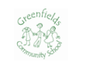
TIME KEEPING AND ATTENDANCE 8.45 - 12.00am / 12.05 - 3.20pm – Part Time Hours 8.45 - 3.20 – Full Time Hours Please be on time dropping off and collecting your child. It is important that your child attends every day to really get the most out of their learning. If your child is ill or unable to attend, please phone the office or let a member of staff know. Thank you.
Thank you.

Dear Parents and Carers,
Welcome back and a warm welcome to all our new families joining
Greenfields Nursery this term.
We want your child to really enjoy taking their first steps on the path of learning with us and hope that you (as parents/carers) will also feel included and enjoy being an important part of our lovely school community.
Foundation Staff
Mrs Thomas and Mrs Lawrence – Foundation Teachers
Miss Cobb and Miss Birch – Teaching assistants

Nursery Autumn Term 2025 Newsletter


Our books this half term are:
CLOTHING UNIFORM IS NOT NECESSARY We ask that your child comes dressed in comfortable clothes (please not their best clothes) as many of our activities involve messy play.
EVERY DAY all children need: a coat (we are outside every day) their bag of joy (reading book and reading diary) a named water bottle (no juice please) a healthy lunchbox (no nuts please)
Please NO hoop earrings-studs only.
Thank you for your continued support, Mrs Thomas and Mrs Fletcher

OURSELVES
During this half term we will be focussing all our learning on the topic ‘I wonder who can help me’ focussing on our family, friends and people who can help us. We will also be talking about who lives in our house – people and pets! We would like to display photos of all our families and would appreciate it if you could send a family photo into Nursery for your child to talk about. Each week in Nursery we will be thinking about a sound, colour, shape and number. These will be displayed on our parents’ board. Please support us by talking to your child about these topics, looking for them at home and in the local environment. Important Dates for the diary Phonics meeting-Monday 22nd Sept 8.45-9.15 Story Café – Tuesday 14th October 8.45-9.30

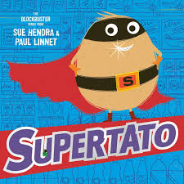
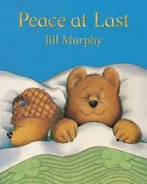

School Website
Please visit www.greenfields.nottingham.sch.uk
to keep up to date with events and news each term. You can find information, class photos and useful websites for you to use at home with your children, so get browsing! 😊

