Hello and welcome to class 6
What an exciting year we have ahead of us!
Below, you will find an outline of our half-term with some reminders.

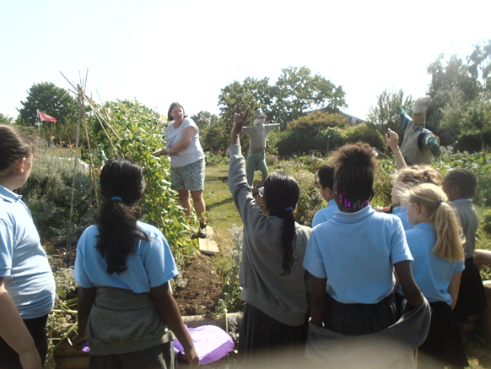
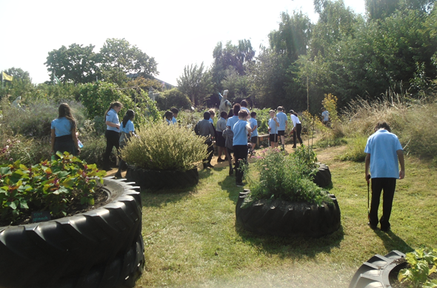

Autumn term

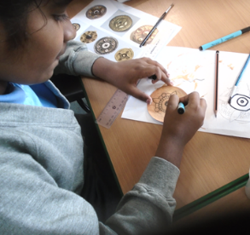
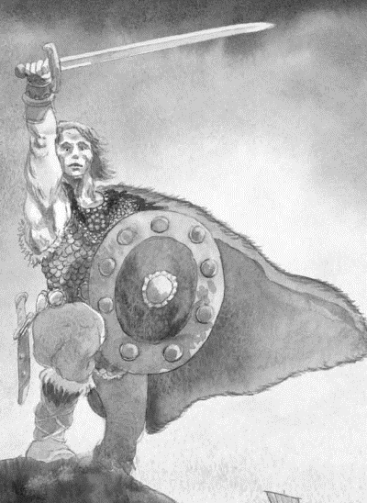
This half-term we’ll be exploring the Anglo-Saxons, as we wonder how they changed Britain. We’ll be developing our historical skills and knowledge to help us establish who they were; where they settled; why they came to Britain, and their impact. We’ll be applying this knowledge within our English lessons too, as we use the stimulus ‘Beowulf’ to write persuasive letters as Lord Hrothgar, and our own versions of the narrative.

Throughout the half-term, in PSHE, we’ll be exploring ‘Me and my relationships’ linking this closely with our Greenfields’ Learning project theme- Care.
Reminders:

Morning doors
Key Stage 2 doors open in the morning at 8.50 am. We ask that pupils arrive promptly as these morning sessions are used to recap learning and practice skills. Gates will shut at 9:00am.


Reading books
Reading is an integral part of our curriculum and school life. We encourage the children to read daily, to develop their reading for pleasure, fluency, knowledge of the world and their comprehension skills. Please fill in your child’s reading diary, each time they read. This is checked weekly.

PE
We have PE once a week, on a Tuesday afternoon. Children should wear white t-shirts, black shorts or bottoms and trainers or pumps.

Homework:
homework, which consists of a piece of maths and English, is handed out on a Friday, and is due in on Thursday. We also want to encourage our pupils to use their TT Rockstars log in to help improve their times table knowledge.

School uniform
All children in school should be wearing full school uniform and black school shoes. Please can you label everything!

E-safety:

In our technological-advancing world, it is important that you regularly monitor your child’s usage. We will continue to educate and raise awareness around being safe online, but ask that this is also encouraged and discussed at home. If you or your child have any concerns, please do not hesitate to speak with us.

https://ee.co.uk/do-more-with-ee/learn/how-to-get-your-child-set-up-safely-on-their-first-device?s_cid=con_ee_dg-home_ess_ppc-generic&esskwid=p80436889387&ess_sacid=71700000119130197&gad_source=1&gclid=Cj0KCQjwrp-3BhDgARIsAEWJ6SwkD7E6Txupd3Lm8EpV1x7pKt_1yM9annzVdK5r_PpzrPu6cdNsD00aArWdEALw_wcB&gclsrc=aw.ds

